Idea 1

“Love is a franchise“

(the thing we are spreading is love culture)

People stopped believing in love and relations. Hook-up culture crushed men and women so hard that they now reside in homes in complete loneliness.

You play as a new CEO of an old secret organization, that was pulling the string all the time civilization existed. Your organization was actually responsible for breaking peoples hearths so hard! But it turned out to be non-profitable and planet population started to decrease.

Your goal is to convince people to love again. Your tools will be mass-media, such as instagram reels, tiktok videos, youtube, radio podcasts. You will pay models to speak love propaganda, that will tell how beautiful is to be loved. You will make movies and write songs that will show what romanticism is. You will open labs to create aphrodisiacs. You will bribe politicians to rewrite laws in your favor. And you will hunt down public persons that will oppose you.

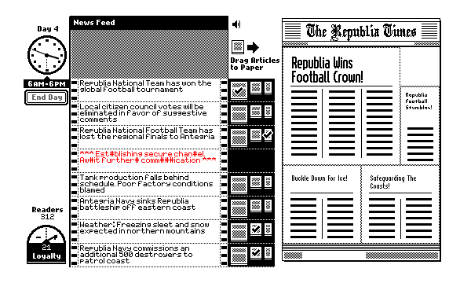Community is already used to fear love. Will you win against it?

Inspired by the game “The Republica Times”, where you play as newspaper editor.

Also some tycoon could take place, like Gamedev tycoon.

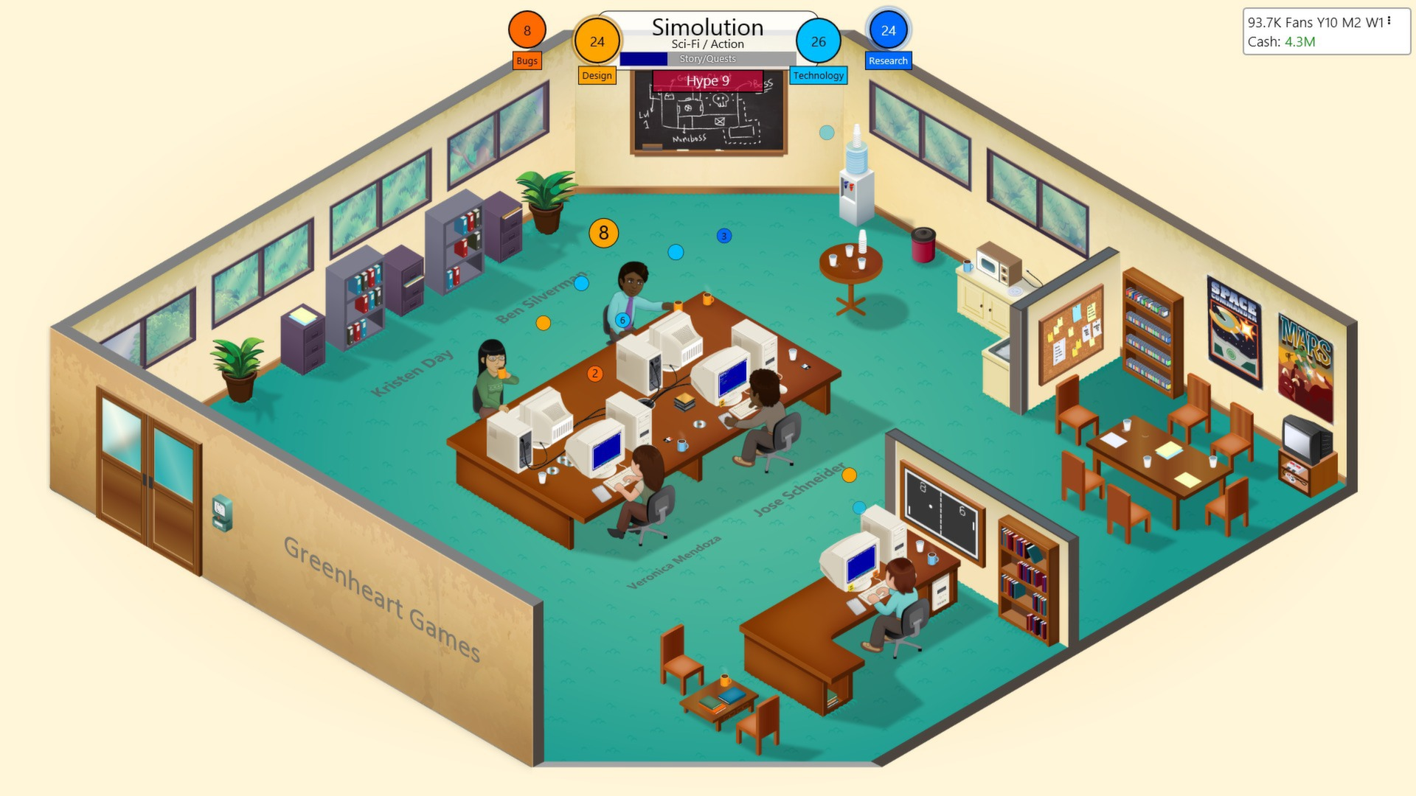

Idea 2

The Fox spirit of The Forest spirits

(the thing we are spreading is foxes population)

One day The Forest Spirits decided to hire a soul of some teenage girl to do a great job – to be a guardian to all the foxes in world. Hunt season just passed, lots of foxes were killed for fur.

That’s why foxes guardian needs to revisit many fox families to help them repopulate and live happily again. Tough job, isn’t it? When you are still half head submerged into your personal problems.

You will play as once ginger, but now pale-white teenage girl, and you already have became to be an immortal being. However don’t get caught by regular people, especially the ones from your circle! You don’t want to scare them with your resurrection from grave.

You also can turn into a white fox! The small body gives you a lot of agility and you can squeeze through small openings. But that also makes you a valuable target for hunters nearby.

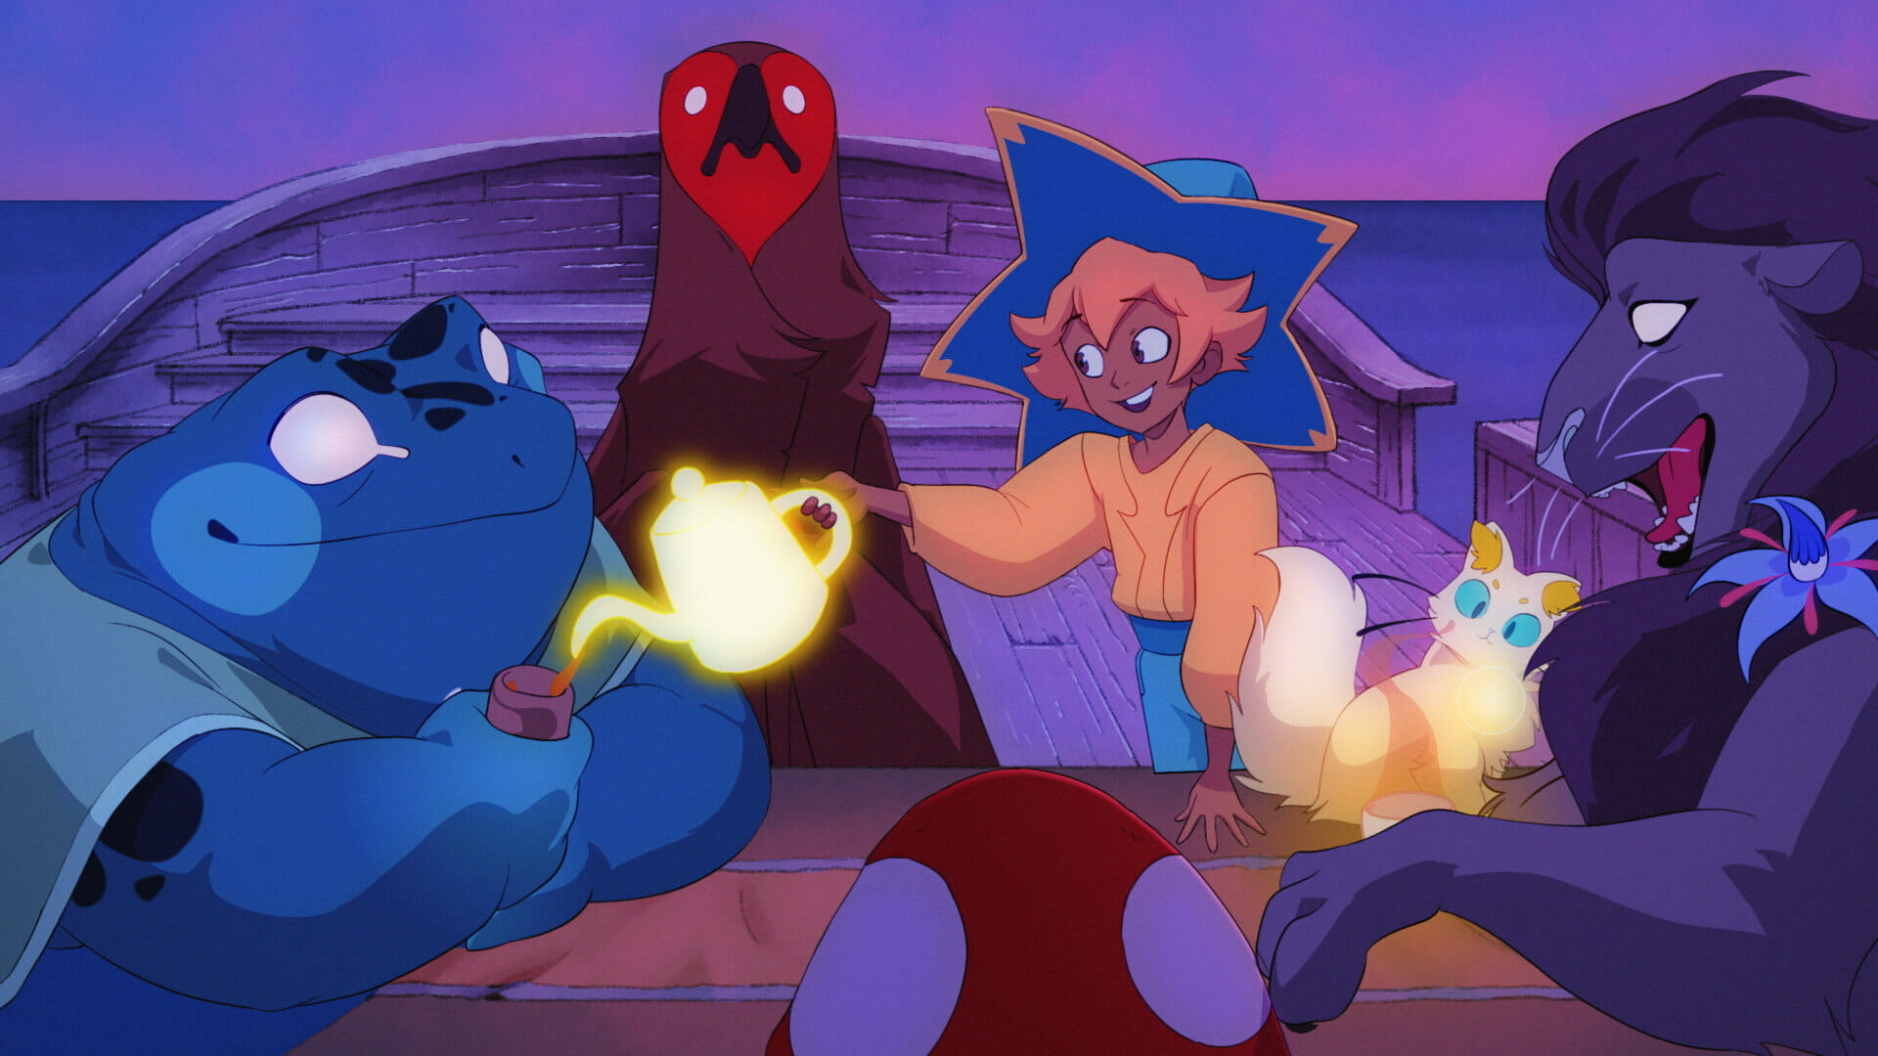

Inspired by Deltarune, Night In The Wood 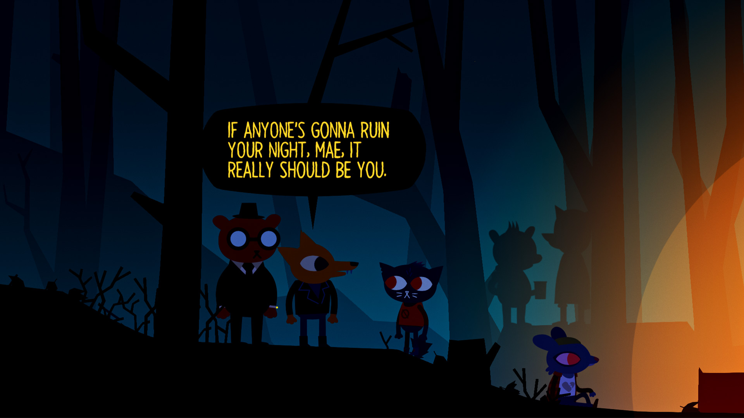and Spiritfarer games.

